B.K. Jewellers

**Business Requirement Document (BRD)**

**Document for**

**“Account management” part.**

Document NO: 001

Date: 10-02-2020

Prepared by:

Group 2

* **Revision History**

|  |  |  |  |
| --- | --- | --- | --- |
| **Revision Number** | **Revision Date** | **Summary of changes** | **Author** |
| **1** | 10/02/2020 | Document made. | Vrajrajsing jadeja |
| **2** | 18/04/2020 | * **Table of content:** Page numbers added. * **(3):** Originator updated * (**4- Pending alerts**)**:** Frequency updated. * **(8):** Note updated. | Rudra soni |
| **3** |  |  |  |
|  |  |  |  |

* **Table of Contents** -

|  |  |  |
| --- | --- | --- |
| Sr. no. | Content | Page no. |
| 1. | Introduction |  |
|  | 1.1 Purpose | 4 |
|  | 1.2 Scope | 4 |
|  |  |  |
| 2. | General business requirement |  |
|  | 2.1 General requirements | 4 |
|  | 2.2 User characteristics | 5 |
|  |  |  |
| 3. | Business requirements | 5 |
|  |  |  |
| 4. | Process description | 8 |
|  |  |  |
| 5. | Use case diagram | 10 |
|  |  |  |
| 6. | Business data model | 11 |
|  |  |  |
| 7. | Accuracy | 11 |
|  |  |  |
| 8. | Impact | 11 |

1. **Introduction**
   1. Purpose:

This Business Requirement document defines the organization’s need regards to the “account department”. It outpours what the “account department” must deliver to capitalize on a business opportunity or to manage business challenges.

* 1. Scope:

The scope of this business requirement document is bounded to only “account department” of **B.K. Jewellers**. The focus in only on the accounting activities of an organization and the actors associated with it.

1. **General business requirements**
   1. General requirements:

* Only one user on one machine.
* Editing invoices.
* Automatic GST calculation on yearly amount of transactions.
* Other low level taxes record and payment checks.
* Salary status of employees.
* Monthly expanses report.
  1. User characteristics:

|  |  |  |
| --- | --- | --- |
| Name | No. Of user | Responsibility/activity |
| Accountant | 3 | He/she have 80% of computer knowledge and at least 85% of knowledge of rules and regulations of organization. |
| Account manager | 1 | He/she have 80% of computer knowledge and 95% of knowledge of rules and regulations of organization and 100% knowledge of GST rules and regulations. |

1. **Business requirement**

|  |  |
| --- | --- |
| 1. | Login |
| Priority | High |
| Originator | Managing director |
| Inputs | Username and password from text fields submit and reset from a button. |
| Operations | When username and password is added, values will validate. |
| Outputs | If successful, user will navigated into software else the text fields will become red. |
| Error handling | If the inputted data is incorrect it will show an alert message “username and password is wrong!!”. |
| User need | User needs this for login to the software. |
| Benefits | First level of security to access the software. |

|  |  |
| --- | --- |
| 2. | Invoice generation |
| Priority | High |
| Originator | Account manager |
| Inputs | Adding items through barcode scanner or by text fields.  Text field for GST and extra charges. |
| Operations | When item is added, finding all related information of it from database.  Automatic GST charges apply for particular item. |
| Outputs | Display the details of item in invoice.  Final price calculated. |
| Error handling | If the data can’t be fetched, the respective input fields will fill up with dashed line and an alert message pops up “Unable to fetch data!!”. |
| User need | User needs this requirement for making invoices. |
| Benefits | Fewer efforts for tax calculation.  Single input and multiple outputs. |

|  |  |
| --- | --- |
| 3. | New item adding to stock |
| Priority | High |
| Originator | Account manager |
| Inputs | Adding item code, weight (gross and net), type, GST and labour through text fields.  Adding images via sourcing .jpg file. |
| Operations | When details are added, a new item is added to its category. |
| Outputs | Display all details which were added. |
| Error handling | If the details can’t be submitted, all inputted data will stay as it is and one alert massage pops up with warning “Item can’t be added please try again after sometime!!” |
| User need | User needs this requirement for adding newly manufactured items into the stock. |

|  |  |
| --- | --- |
| 4. | Bank account maintenance. |
| Priority | High |
| Originator | Account manager |
| Inputs | Importing MS Excel sheet, specially used for transaction records. |
| Operations | Depend on MS Excel. |
| Outputs | Display the details in order in which they are added. |
| Error handling | Depend on MS Excel. |
| User need | User needs this requirement for tracking bank activities and balance in account (on name of organization). |
| Benefits | No need to interact with bank for transaction details every time. |

|  |  |
| --- | --- |
| 5. | GST filling |
| Priority | High |
| Originator | Account manager |
| Inputs | Enter GST number in text field of website.  Uploading invoices on GST web site. |
| Operations | Defined by the government & rules for GST filling. |
| Outputs | Defined by the government & rules for GST filling. |
| Error handling | If there is any error in invoices, it can be solved or edited by correct values in respective fields of the invoices. |
| User need | User needs this requirement for filling GST online within organization. |
| Benefits | No need of external support. |

|  |  |
| --- | --- |
| 6. | Salary status |
| Priority | High |
| Originator | Account manager |
| Inputs | Importing MS Excel sheet, specially used for salary records. |
| Operations | Depend on MS Excel. |
| Outputs | Display the details in order in which they are added. |
| Error handling | Depend on MS Excel. |
| User need | User needs this requirement for tracking the salary status of each employee. |

1. **Process description**

|  |  |
| --- | --- |
| Details | Process Description |
| Process Name | Login |
| Purpose | It should be the first process for entering to software. |
| Priority | High |
| Frequency/Duration | Login process should not more than 2seconds to complete and navigate the user to the main page of the software. |

|  |  |
| --- | --- |
| Details | Process Description |
| Process Name | Invoice generation |
| Purpose | It is the process for entering invoices by accounting department to software. |
| Priority | High |
| Frequency/Duration | Invoice generation process should not take more than 2seconds to complete and navigate the user to the invoice printing option. |

|  |  |
| --- | --- |
| Details | Process Description |
| Process Name | Pending alerts |
| Purpose | It should be the first process for after entering to software, and it is used for completing the pending tasks first. |
| Priority | High |
| Frequency/Duration | Alert generation process should not more than 2seconds to complete and display result in small block. |

|  |  |
| --- | --- |
| Details | Process Description |
| Process Name | GST filling |
| Purpose | It the process for calculating and filling the government service tax via software. |
| Priority | High |
| Frequency/Duration | GST filling process should not more than 10seconds to complete after registering the details. |

|  |  |
| --- | --- |
| Details | Process Description |
| Process Name | Salary status |
| Purpose | This process is required to keep salary records of an employee. |
| Priority | High |
| Frequency/Duration | Status process should not more than 3seconds to complete after functioned. |

|  |  |
| --- | --- |
| Details | Process Description |
| Process Name | Bank account maintenance. |
| Purpose | This process is for tracking bank account transaction(no bank account linked, entry by manually) |
| Priority | High |
| Frequency/Duration | This process cannot take more than 2seconds to complete basic math functions on numbers registered by accountant. |

1. **Use case diagram**

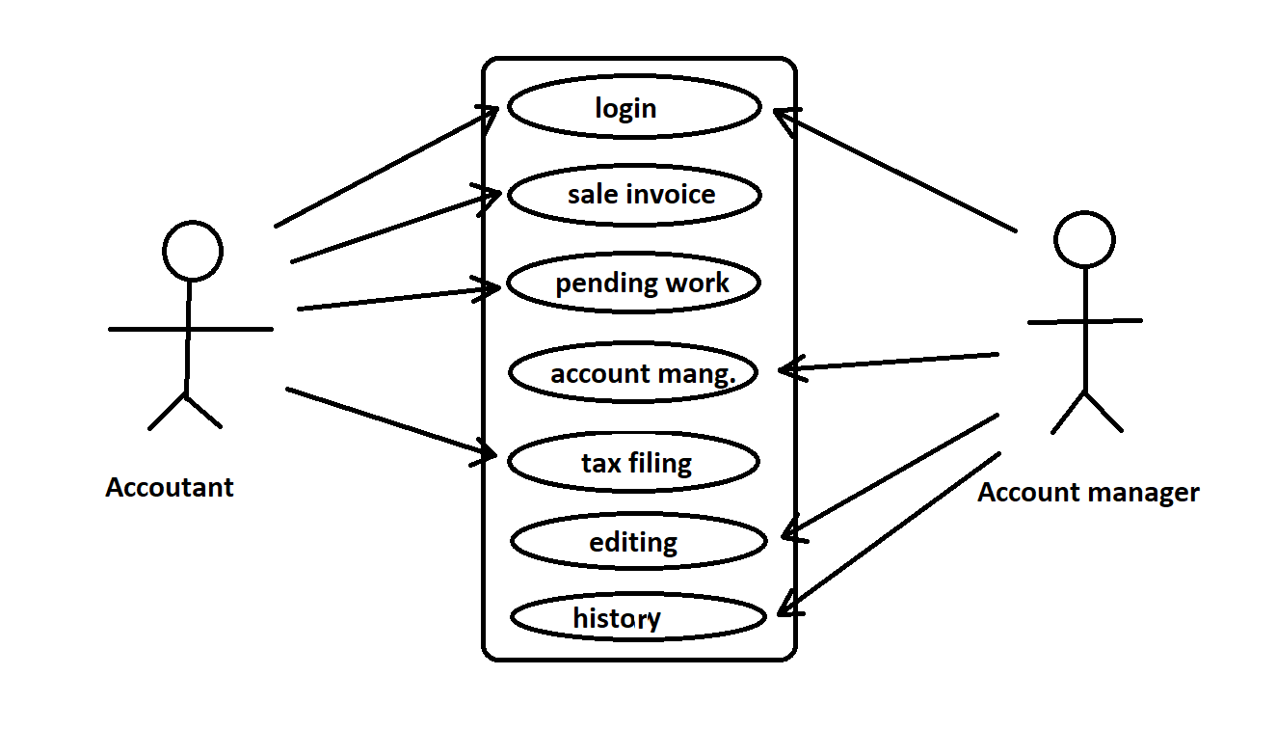

|  |  |
| --- | --- |
|  | Indicates software. |
|  | Indicates modules. |
|  | Indicates access/rights. |
|  | Indicates users. |

1. **Business data model**

**---------(N/A)---------**

Note: insufficient knowledge.

1. **Accuracy**

The accuracy will always be higher in any of the functions which can be done by the software even in printing the invoices. All the automatic processes will be completed with very high level of accuracy in the results generated by them.

1. **Impacts**

**---------(N/A)---------**

Note: Software being made first time.